**INSTRUCTIONS FOR SETTING UP DOG CAR SEAT**

*Firstly, setting up the dog car seat is all very easy.*

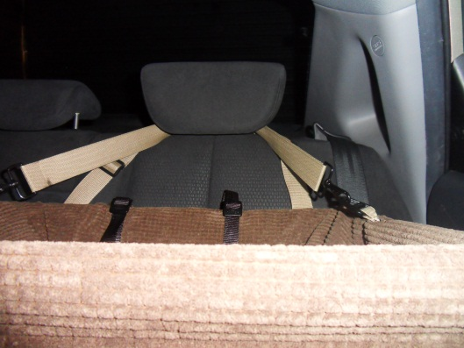You just need to place both straps over your headrest, without your dog in it, with the back strap facing the back of the seat. You then need to adjust both straps accordingly. The tighter you adjust them the further the dog car seat moves up, so it is up to the individual and the size of the dog as to how high you want the seat. It is just a matter of playing around with the straps, until you get the seat at the right height. Both straps need to be adjusted evenly so that the seat is horizontal*. (See photo, straps over headrest.)*

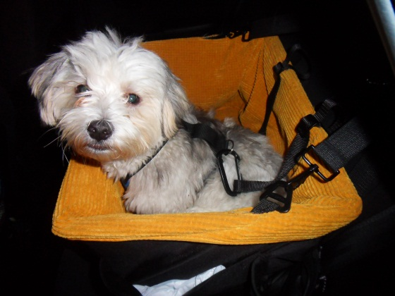Once you have established this, then you are ready to put your dog in, making sure he has his harness on. You can then clip him in with either strap inside the dog car seat. Clipping him in with the clip furthest away from the door, would keep him further from the window. When you decide which clip to use, just clip this through the harness where you would normally put the lead and then adjust this strap to the length you want. The tighter the strap the less he gets to move around, but the longer the strap gives him more room in the seat. Once again this is personal preference depending on the size of your dog and what limitations you want it to have. Obviously if you have two dogs, you just use both clips and do the same thing*.*

*(See photo, dog in seat, with clip through dog harness).*

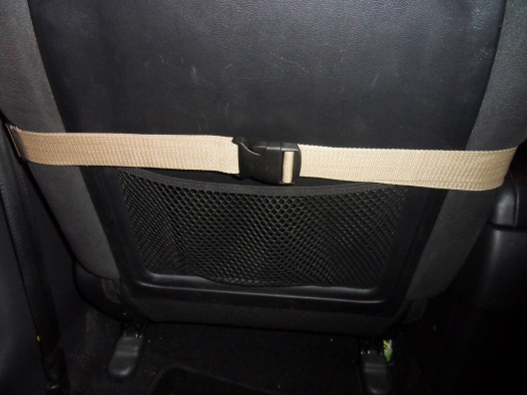Should you want to use your dog car seat in the front seat of the car, you also have the option of being able to put the back strap around the back of the seat in the car. (This is also an option in the back, if your seats lay down.) The strap with the clip, this is the longer one, you wrap around the seat and then adjust until it is tight. You may have some excess strap, which you just tuck behind the strap itself. (*See photo, strap wrapped behind front seat.)*

Some customers have also wound the strap around the actual headrests themselves, keeping it even more secure. This would probably be a longer term solution if you do not have to move the seat around a lot.

Should you not understand or have any further problems, please do not hesitate to contact us. You can email us on: ***dogcarseat@gmail.com*** **(www.dogcarseat.com.au)**